Lab2

Jiahuan Li

2023-01-25

afdat <-  
 read.csv("d:/Users/Lijh/Desktop/710 R & statistics/lab2/AfrPlots.csv",  
 header = TRUE)  
library(ggplot2)

## Problem 1

### a

#### histogram

MeanGr1 = afdat$MeanGr[!is.na(afdat$MeanGr)]  
MeanGr2 = as.data.frame(MeanGr1)  
  
dukeblue <- "#00009C"  
 ggplot2::ggplot(afdat, aes(x = MeanGr)) + geom_histogram(fill = dukeblue, colour = "white", bins = 20)

+ xlab(expression(paste("Average DBH difference", " (cm)")))

+ ylab("Count")

+ ggtitle('Figure 1: Distribution of the difference in average DBH (cm) during the census')

+ theme_bw()

*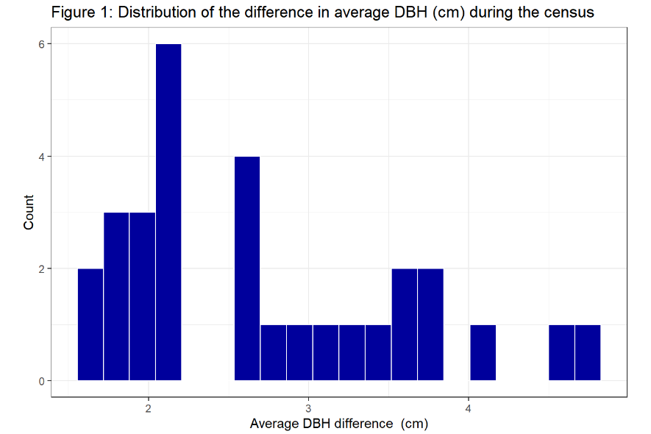**boxplot*

ggplot2::ggplot(afdat, aes(x = MeanGr, y = "")) + stat_boxplot(geom = "errorbar", width = 0.15, color = 1)

+ geom_boxplot(fill = dukeblue, alpha = 0.5, color = 1, outlier.colour = 2)

+ xlab(expression(paste("Average DBH difference", " (cm)"))) + ylab("")

+ ggtitle('Figure 2: Boxplot of the distribution of the average DBH (cm) difference') + theme_bw()

### b

kurtosis <- function(y) {  
 n <- length(y)  
 kurt <- 1 / (n * sd(y) ^ 4) * sum((y - mean(y, na.rm = TRUE)) ^ 4) - 3  
 kurt  
}  
  
MeanGr1 = afdat$MeanGr[!is.na(afdat$MeanGr)]  
answer = kurtosis(MeanGr1)  
print(paste("answer =", answer))

## [1] "answer = -0.728889486347993"

### c

library (scales)  
  
Mean = mean(afdat$MeanGr, na.rm = TRUE)  
Median = median(afdat$MeanGr, na.rm = TRUE)  
Sd = sd(afdat$MeanGr, na.rm = TRUE)  
COV = percent(Sd / Mean, accuracy = .01)  
  
print(paste("Mean =", Mean))

## [1] "Mean = 2.70576275873333"

print(paste("Median =", Median))

## [1] "Median = 2.58466596"

print(paste("Sd =", Sd))

## [1] "Sd = 0.894471691835576"

print(paste("COV =", COV))

## [1] "COV = 33.06%"

## Problem 2

### a

p1 = sum(dbinom(6:20,20,0.5))  
p2 = pbinom(q = 5, 20, 0.5, lower.tail = FALSE)  
  
print(paste("Answer from dbinom =", p1))

## [1] "Answer from dbinom = 0.979305267333984"

print(paste("Answer from pbinom =", p2))

## [1] "Answer from pbinom = 0.979305267333984"

### b

pbi = function (x, n, p) {  
 bi = factorial(n)/(factorial(x)*factorial(n-x))*p^x*(1-p)^(n-x)  
 bi  
}  
  
p3 = sum(pbi(6:20,20,0.5))  
print(paste("Answer from equation =", p3))

## [1] "Answer from equation = 0.979305267333984"

## Problem 3

p_17_correct = pbinom(16, 20, 0.25, lower.tail = FALSE)  
p_17_correct1 = sum(dbinom(17:20, 20, 0.25))  
  
print(paste("Probability of answering 17 or more answers correctly =", p_17_correct1))

## [1] "Probability of answering 17 or more answers correctly = 2.96049620374107e-08"

## Problem 4

### a

p_9 = dpois(9, 4)  
Poiss = function (x, l) {  
 pois = l^x/factorial(x)*exp(-l)  
 pois  
}  
q4_1 = Poiss(9,4)  
  
print(paste("P(X = 9) =", q4_1))

## [1] "P(X = 9) = 0.0132311916910503"

### b

P_9_13 = sum(dpois(9:13,4))  
P_9_13_1 = ppois(13,4) - ppois(8,4)  
P_9_infinite = ppois(8, 4, lower.tail = F)  
P_9_infinite_1 = 1 - sum(dpois(0:8, 4))  
  
print(paste("answer for P(X >= 9) using dpois() is", P_9_13, "with limitation of the maximum number as 13"))

## [1] "answer for P(X >= 9) using dpois() is 0.0212871060726408 with limitation of the maximum number as 13"

print(paste("answer for P(X >= 9) using ppois() is", P_9_13_1, "with limitation of the maximum number as 13"))

## [1] "answer for P(X >= 9) using ppois() is 0.0212871060726408 with limitation of the maximum number as 13"